# Adrenal insufficiency associated with advanced HIV may explain the high mortality.

## TRP Mofokeng1, A Grossman3, RS Millar5, TS Pillay6, J Sempa7, J Singbo, J Dave2, NS Levitt2, R Erasmus2, PJ Raubenheimer2, C Dandara2, G Johansson4, IL Ross2

1Division of Endocrinology, Department of Medicine University of the Free State, South Africa 2Division of Endocrinology, Department of Medicine University of Cape Town, South Africa 3Department of Endocrinology, St Bartholomew’s Hospital, London, UK

4Department of Endocrinology, Sahlgrenska Academy, Sahlgrenska University Hospital and Institute

of Medicine, University of Gothenburg, Gothenburg, Sweden

5Department of Immunology, Faculty of Health Sciences, University of Pretoria, Private Bag X323, Pretoria 0031, South Africa

6Department of Chemical Pathology and National health Laboratory Servi Tshwane Academic Division, Faculty of Health Sciences, University of Pretoria, South Africa

7Department of Statistics University of the Free State, South Africa

Correspondence should be addressed to: Dr Thabiso RP Mofokeng,

Division of Endocrinology,

Department of Medicine (University of the Free State) South Africa,

e-mail: [mofokengtrp@ufs.ac.za](mailto:mofokengtrp@ufs.ac.za)

09-12-24

### Abstract:

**Background:**

Sub-Saharan Africa is burdened by a vast HIV-positive population, at risk of life-threatening AIDS defining illnesses and disseminated opportunistic infections, which have been associated with both primary adrenal insufficiency (PAI) and secondary adrenal insufficiency (SAI). We hypothesized that adrenal insufficiency (AI) may partially account for the high mortality in advanced HIV.

### Materials & Methods:

We undertook a prospective case-finding study of HIV-positive patients presenting with advanced disease who were 18 years or older, with a CD4 count of less than 100 cells/ mm3, and a coexistent opportunistic infection. Exclusion criteria were use of oral, intravenous, topical or inhaled steroids in the previous 3 months. A tetracosactide test was performed in patients with morning random cortisol concentrations of less than 500 nmol/L.

### Results:

A total of 559 patients were recruited, of these, 549 complete records were evaluated. The median interquartile range (IQR) age of patients at enrolment was 36.0years (IQR: 31.0-43.0). The majority were Black Africans 75.7% and mixed race (22.9%), whites and Asians in (1.2%) and (0.3%), respectively. Of the 549 patients 33 (6.01%) had AI, of whom 24 (72.72%) had (SAI) whereas 9 (27.27%) had (PAI). Overall, 151 tetracosactide tests were performed identifying 27 AI patients. Extra Pulmonary tuberculosis (EPTB) and cryptococcus neoformans predominate in the AI group, whereas pulmonary tuberculosis (PTB) predominates in the group without AI 33.3% vs 19.0%, *p*=0.045, 30.3% vs 3.8%, *p*<0.001, and 42.4% vs 64.7%, *p*=0.01, respectively. The DBP was higher in AI versus Non-AI group 73.0 (66.4,80.8) versus 70.0 (60.0, 79.0) *p*=0.012. Diflucan and Opiate use was higher in the AI versus Non-AI group: 33.3% versus 12.1% and 36.4% versus 21.9%, with *p*=0.002 and p=0.054, respectively. Duration of illness was longer in the SAI versus PAI group: 14days (IQR:14.0, 27.8) versus 10 days (IQR: 7.0, 14.0), *p*=0.006. Although mortality was not different in the AI vs non-AI groups, it was higher in patients with AI patients with cryptococcus neoformans 45.5% versus 4.3, *p*<0.001. The overall one-year mortality was 151/549 (27.50%). Regression analysis revealed that a 50 nmol/L cortisol increase, and 50 pg/L increase in the plasma ACTH was associated with a 13% and 1% increase in the odds of mortality (OR = 0.56, (95%CI: 1.07, 1.19), *p*<0.001) and (OR = 1.00, (95%CI:1.00, 1.01), *p<*0.013), respectively.

### Conclusion:

The largest longitudinal study on hypoadrenalism in advanced HIV in Africa revealed overall one year mortality of 27.50%.

PTB – pulmonary tuberculosis, EPTB – Extrapulmonary tuberculosis

### Introduction:

Adrenal insufficiency (AI) resulting from deficiency of glucocorticoids and mineralocorticoids is an invariably fatal medical condition without replacement. Prior to the availability of glucocorticoids, the majority of patients with primary adrenal insufficiency (PAI) died within 2 years of diagnosis(1).

Autoimmune adrenal insufficiency predominates in European populations,(2) and in South Africa (3), despite the high background prevalence of tuberculosis (TB) in the latter, compared with the former regions (4). Our recent survey suggests that TB (34%) and Acquired Immune Deficiency Syndrome (AIDS) (29.8%) predispose to the development of PAI (5).

The background prevalence of Human Immunodeficiency Virus (HIV) in sub-Saharan Africa is 9%(6)((7). The mortality in HIV positive patients is higher in resource limited settings for example, sub-Saharan Africa, (8) due to late presentation and inadequate health resources. Patients with HIV may develop PAI due to *inter alia* TB, *Mycobacterium avium Intracellulare* (MAI), cytomegalovirus (CMV), toxoplasmosis, *Pneumocystis carinii*, histoplasmosis and malignancies for example, non-Hodgkin’s lymphoma and Kaposi sarcoma (KS). Additionally, fungal infections including cryptococcus, blastomycosis, and histoplasmosis and medications for example, ketoconazole and mitotane may precipitate PAI. (9) Secondary adrenal insufficiency (SAI) may also be caused by *inter alia* TB, toxoplasmosis and CMV in HIV infection(10-12).

There are varied results indicating the incidence of hypoadrenalism in patients with HIV. In a study in Pakistan of 64 HIV infected, predominantly male patients (84.9%), AIwas reported in 9 (14.0%), using the 250 microgram intravenous tetracosactide test and a 60 minutes cortisol concentration of less than 18 microgram/dl (500 nmol/L), (13) whereas in a Nigerian study of 43 newly diagnosed HIV positive patients who were antiretroviral treatment naïve, the AI incidence was 34.8%, using a 1 microgram tetracosactide test (14) and a 30 minute cortisol of less than 500 nmol/L.

Despite optimal replacement therapy in AI in general, patients demonstrate poorer survival due in part to cardiovascular, malignant and infectious diseases, compared to background populations(10, 15). Both overtreatment and insufficient replacement with glucocorticoids during infections and stress-related events confer an increased mortality (16).

We hypothesized that coexistent AI among patients with advanced HIV may accelerate mortality. Our objectives were to determine the incidence of AI among ill, hospitalized HIV-infected patients. In addition, we wished to explore the positive predictive clinical and biochemical characteristics for AI, and the predictors for survival.

### Materials and methods:

Approval to conduct the study (HREC 163/2015) was obtained from the University of Cape Town Faculty of Health Sciences, Human Research and Ethics Committee, which endorses the latest Helsinki declaration of 2013. We undertook a prospective case-finding study of HIV positive patients, presenting with advanced disease and an opportunistic infection to an acute tertiary care medical ward. All the participants provided written informed consent. If participants were affected by delirium our research and ethics committee endorsed retrospective informed consent, with a view to limiting bias and providing an equal opportunity for life-saving treatment.

***Inclusion and exclusion criteria***

Inclusion criteria included age 18 years and older, and a CD4 count of 100 cells per mm3 or fewer and an opportunistic infection. The use of oral, topical or inhaled steroids in the previous 3 months represented an exclusion criterion.

***Data extraction***

Patients who met the inclusion criteria had blood samples taken for serum cortisol and plasma ACTH between 08:00 and 09:00 on the day of enrolment. Demographic and clinical data were obtained from history and physical examination. Records of routine biochemistry, haematology and microbiology were extracted from the National Health Laboratory Service (NHLS) repository. Where the random serum cortisol was less than 500 nmol/L, a short 250 µg intravenous tetracosactide stimulation test was performed, usually on the following day.

***Biochemical measures of plasma ACTH and serum cortisol***

Due to the unavailability of the gold standard LC/MS cortisol diagnostic test (17) which is considered to be superior to the available **e**lectro**c**hemi**l**uminescence **i**mmuno**a**ssay (ECLIA) tests, we went ahead with the Roche COBAS ECLIA tests for both cortisol and ACTH concentrations. For the random plasma ACTH, the specimen was collected in anticoagulated containers and immediately frozen and for serum cortisol concentration, clotted bloods were submitted to a private accredited laboratory (Lancet), which analyzed the samples on the Roche Cobas “ECLIA”.

**Methodology for serum**

Serum cortisol concentrations were assayed under Roche Cobas 6000 e601 module using the Elecsys Cortisol II reagent at Groote Schuur hospital. Serum cortisol concentrations were determined using Electro luminescence assay (ECLIA). In this competitive immunoassay, the patient’s endogenous cortisol is II incubated with a cortisol-specific biotinylated antibody and a ruthenium-labelled cortisol derivative following treatment with danazol to liberate endogenous cortisol from its binding proteins. The resultant ruthenium-labelled immune complex is later coated with streptavidin microparticles. A voltage is applied which induces a chemoluminescent emission that is measured by a photomultiplier tube. Results are read off a calibration plot that is generated by 2-point calibration and off a master curve provided via the reagent bar codes from the manufacturers. This method has been standardized against the institute for reference materials and measurements in brackets (IRMM)/IFCC-45 panel. The measuring range is 1.5 nmol/L to 1750 nmol/L with a limit of detection (LOD) of 1.5 nmol/L (18).

***The tetracosactide test***

The samples of plasma ACTH collected in Ethylenediaminetetraacetic acid (EDTA) tubes on ice and serum cortisol obtained during the test were submitted to the National Health Laboratory Services (NHLS) for testing using the Roche electrochemiluminescence immunoassay “ECLIA”. Blood was taken at 0 minutes for serum cortisol, followed by 250 µg of intravenously administered tetracosactide and a 30-minute serum cortisol was taken at the conclusion of the test. AI was diagnosed if a 30-minute serum cortisol was less than 500 nmol/L. In patients with confirmed cortisol deficiency, a concomitant plasma ACTH above the upper limit of the reference range (67.7 pg/mL) was consistent with PAI, (17) while a low or normal plasma ACTH was diagnostic of SAI (18). Further cortisol analysis was done to evaluate the diagnostic sensitivity and specificity of stimulated cortisol concentration at 420 nmol/L, 400 nmol/L, and 340 nmol/ L.

***Determination of survival***

Telephonic follow-up was performed to determine after discharge survival from hospital through direct patient or family contact. A hospital database (Clinicom®) also corroborated survival, by their attendance at various clinics in the drainage area of our tertiary hospital facility.

### Statistical analysis:

Statistical analyses were performed using R-programing software *(ref: R Core Team (2023). _R: A Language and Environment for Statistical Computing_. R Foundation for Statistical Computing, Vienna, Austria. https://*[*www.R-project.org/)*.](http://www.R-project.org/)) Categorical variables were presented as frequencies and percentages, and continuous variables were expressed as medians and were compared using the Wilcoxon-Mann-Whitney test. Proportions and categorical variables were compared, using Pearson’s chi- square test or Fisher’s exact test as appropriate. We ranked CD4 counts into tertiles of 0-33; 34-66 and 67-100, respectively to determine if AI was associated. Univariate Cox-Proportional Hazard regression was used to estimate the of each variable on mortality. Multivariable Cox-Proportional Hazard regression analysis was used to identify independent predictors of survival. The significance level was set at *p* <0.005. For analysis of survival data, we described those who were discharged from the hospital and evaluated within 3 months (early survivors), followed by 6 months (intermediate survivors), and 12 months follow- up (late survivors).

**Consort Here!**

### Results:

A total of 559 patients were recruited, of whom 10 withdrew from participation and 549 participants were included in the final analysis. Most of the patients were female 280 (51.1%) and the predominant opportunistic infection was tuberculosis in 461 (84%), followed by pneumonia 62 (11.3%), candida 34 (6.2%), and cryptococcus infection in 30 (5.5%). The median, interquartile range (IQR) age at enrollment was 36 years (31.5-43.0) years and when subdivided by CD4 count, patients were significantly younger in the lowest CD4 tertile, 35 years (30.5-42.0); *p*=0.008, compared to the remaining tertiles. See Table 1.

The distribution of gender and ethnicity did not differ by CD4 distribution. Duration of illness was longer in the highest CD4 tertile; *p*=0.036. As expected, the participants with lowest CD4 count, had the highest viral load; *p*=0.001. The white cell, and lymphocyte counts were lower in the lowest CD4 tertile, *p*<0.001 and *p*=0.011, respectively, compared with the remaining tertiles.

The occurrence of opportunistic infections for example, tuberculosis, pneumonia, and cryptococcus did not differ across the CD4 tertiles, except for candida which was highest in the lowest CD4 count, .

### HAART vs HAART naïve

When comparing the subgroup of patients receiving HAART, compared with those who were antiretroviral treatment naïve, the patients did not differ apart from the incidence of Cryptococcus infection which was greater in the treatment naïve group, compared with those patients on HAART at 24 (7.0%) versus 6 (2.6%) *p*=0.039. Importantly the CD4 counts and viral load did not differ between these two groups.

**Clinical characteristics**

**Table 1: Patient presentation by CD4 count in tertiles**

|  |  |  |  |  |
| --- | --- | --- | --- | --- |
| **Variable** | **0 - 33**, *N* =  2731 | **34 - 66**, *N* =  1531 | **67 - 100**, *N* =  1221 | ***p*-value**2 |
| Age at enrolment, median (IQR) | 35.0 (30.0, | 37.0 (32.0, | 38.0 (33.0, | **0.008** |
| (years) | 42.0) | 43.0) | 46.0) |  |
| Gender, *N*(%) |  |  |  | 0.2 |
| Female | 139 (50.9%) | 86 (56.2%) | 55 (45.5%) |  |

|  |  |  |  |  |
| --- | --- | --- | --- | --- |
| Duration of current illness, median | 14.0 (14.0, | 14.0 (11.8, | 14.0 (7.0, 21.0) | **0.036** |
| (IQR) (days) | 21.0) | 21.8) |  |  |
| Weight loss | 233 (87.6%) | 130 (87.2%) | 94 (83.2%) | 0.5 |
| log10 viral load | 11.6 (9.3, | 8.9 (6.3, 12.3) | 7.3 (3.9, 10.6) | **<0.001** |
|  | 12.8) |  |  |  |
| **Opportunistic infections** |  |  |  |  |
| Tuberculosis | 231 (84.6%) | 132 (86.3%) | 100 (82.0%) | 0.6 |
| Pneumonia | 30 (11.0%) | 19 (12.4%) | 13 (10.7%) | 0.9 |
| Candida | 22 (8.1%) | 11 (7.2%) | 2 (1.6%) | **0.049** |
| Cryptococcus neoformans | 16 (5.9%) | 5 (3.3%) | 9 (7.4%) | 0.3 |
| Gastroenteritis | 12 (4.4%) | 7 (4.6%) | 4 (3.3%) | 0.8 |
| Hepatitis B | 9 (3.3%) | 8 (5.2%) | 1 (0.8%) | 0.12 |
| Syphilis | 8 (2.9%) | 8 (5.2%) | 1 (0.8%) | 0.11 |
| Kaposis sarcoma | 6 (2.2%) | 0 (0.0%) | 0 (0.0%) | 0.056 |
| Urinary tract infection | 4 (1.5%) | 0 (0.0%) | 3 (2.5%) | 0.2 |
| Pneumocystis Jiroveci Pneumonia | 4 (1.5%) | 1 (0.7%) | 0 (0.0%) | 0.5 |
| Herpes simplex virus | 3 (1.1%) | 4 (2.6%) | 1 (0.8%) | 0.4 |
| Bacterial meningitis | 3 (1.1%) | 1 (0.7%) | 2 (1.6%) | 0.8 |
| **Haematological parameters**  White cell count x109 | 5.1 (2.9, 7.4) | 5.8 (4.2, 8.5) | 6.8 (4.5, 9.7) | **<0.001** |
| Lymphocyte count x109 | 0.6 (0.3, 1.3) | 0.9 (0.5, 4.9) | 1.3 (0.8, 3.0) | **0.011** |
| Neutrophils x109 | 2.4(1.0,5.9) | 6.6(1.9,15.2) | 5.1(2.9,115 | **0.003** |
| **Medical history** |  |  |  |  |
| HAART exposure | 101 (37.0%) | 62 (40.5%) | 44 (36.1%) | 0.7 |
| Anti-tuberculous therapy | 5 (1.8%) | 3 (2.0%) | 6 (4.9%) | 0.2 |
| Antifungal therapy | 2 (0.7%) | 1 (0.7%) | 3 (2.5%) | 0.3 |

*1* Median (IQR); 2Wilcoxon rank sum test; Pearson's Chi-squared test; Fisher's exact test IQR-interquartile range

TB-tuberculosis

HAART Highly active antiretroviral therapy

### Diagnosis of adrenal insufficiency

Initial screening cortisol concentrations performed between 8 AM and 9 AM, demonstrated that patients with AI patients had a median random cortisol 332 nmol/L (252.0-382.0), compared to 478 nmol/L (372.5- 578.0) patients without AI; *p*<0.001. The stimulated median cortisol was 379 nmol/L (324.5-440) with 27 of 151 patients failing the test, predominantly SAI in 20 and 7 PAI, respectively. Six patients with low random cortisol concentration who did not receive the stimulation test had a preliminary classification of SAI (5) and PAI (1), respectively. Hence, the total AI was 33 with 24 SAI and 9 PAI.

### Adrenal insufficiency

Extrapulmonary tuberculosis and cryptococcal infection occurred more often in the AI, compared with the remaining group, whereas pulmonary tuberculosis occured less often among patients diagnosed with AI. The Diastolic BP was surprisingly higher in the AI group, *p*=0.012. There was greater use of fluconazole and opiates the AI vs the group without 11 (33.3%) vs 63 (12.1%); *p*<0.002 and 12 (36.4%) vs 114 (21.9%); *p*=0.054,

respectively (Table 2).

**Table 2: Comparison of clinical characteristics in patients with adrenal insufficiency with those without**

|  |  |  |  |
| --- | --- | --- | --- |
| ***Variable*** | ***AI, N = 331*** | ***Non-AI, N = 5211*** | ***p- value2*** |
| Age at enrolment, median (IQR) (years) | 39.0 (33.0, 44.0) | 36.0 (31.0, 43.0) | 0.4 |
| Female gender, N (%) | 16 (48.5%) | 266 (51.2%) | 0.8 |
| Duration of current illness, median (IQR) (days) | 14.0 (14.0, 21.0) | 14.0 (11.8, 21.0) | 0.7 |
| Weight loss | 28 (84.8%) | 429 (86.3%) | 0.8 |
| Viral load (log10 copies/mL) | 11.6 (11.0, 11.9) | 10.7 (7.0, 12.4) | 0.6 |
| Pulmonary tuberculosis | 14 (42.4%) | 337 (64.7%) | **0.01** |
| Extrapulmonary tuberculosis | 11 (33.3%) | 99 (19.0%) | **0.045** |
| Cryptococcus neoformans | 10 (30.3%) | 20 (3.8%) | **<0.001** |
| Pneumonia | 4 (12.1%) | 58 (11.1%) | 0.8 |
| Hepatitis B | 3 (9.1%) | 15 (2.9%) | 0.085 |
| Candida | 1 (3.0%) | 34 (6.5%) | 0.7 |
| Kaposis sarcoma | 1 (3.0%) | 5 (1.0%) | 0.3 |
| Herpes simplex virus | 1 (3.0%) | 7 (1.3%) | 0.4 |
| Gastroenteritis | 0 (0.0%) | 23 (4.4%) | 0.4 |
| Total CD4 count | 36.0 (15.0, 58.0) | 34.0 (15.0, 63.0) | >0.9 |
| White cell count X109/L | 5.2 (3.0, 8.0) | 5.6 (3.8, 8.2) | 0.7 |
| Lymphocyte count X109/L | 1.1 (0.6, 1.3) | 0.8 (0.4, 2.0) | 0.4 |
| Neutrophils x109/L | 1.6 (1.0, 3.4) | 3.7 (1.5, 9.0) | 0.086 |
| Sodium mmol/L | 135.0 (132.0, 137.0) | 133.0 (130.0, 137.0) | 0.14 |
| Potassium mmol/L | 4.0 (3.3, 4.7) | 4.1 (3.6, 4.6) | 0.6 |
| Haemoglobin g/dL | 9.5 (7.7, 10.6) | 8.7 (7.4, 10.3) | 0.2 |
| BP (systolic) | 120.0 (103.8, 129.3) | 112.0 (102.0, 125.0) | 0.2 |
| BP (diastolic) | 73.0 (68.3, 80.8) | 70.0 (60.0, 79.0) | **0.012** |
| Heart rate | 86.5 (77.0, 102.8) | 91.0 (79.3, 109.0) | 0.5 |
| Hypotension | 2 (6.1%) | 46 (9.3%) | 0.8 |
| Weakness | 27 (81.8%) | 421 (85.1%) | 0.6 |
| Tiredness | 29 (87.9%) | 422 (85.1%) | 0.8 |
| Poor appetite | 27 (81.8%) | 374 (76.0%) | 0.4 |
| Increased pigmentation of the skin | 13 (43.3%) | 247 (50.9%) | 0.4 |
| Nausea | 21 (63.6%) | 262 (52.9%) | 0.2 |
| Vomiting | 11 (33.3%) | 137 (27.7%) | 0.5 |
| Liking for salt | 20 (60.6%) | 264 (53.5%) | 0.4 |
| Hypoglycaemia | 0 (0.0%) | 11 (2.2%) | >0.9 |
| Loss of consciousness | 0 (0.0%) | 7 (1.4%) | >0.9 |
| Diarrhoea | 12 (36.4%) | 220 (44.8%) | 0.3 |
| Dizziness | 18 (56.3%) | 236 (47.9%) | 0.4 |
| Shock | 0 (0.0%) | 5 (1.0%) | >0.9 |

|  |  |  |  |
| --- | --- | --- | --- |
| Anorexia | 14 (42.4%) | 233 (47.2%) | 0.6 |
| Loss of axillary and pubic hair, if female | 5 (15.2%) | 95 (18.9%) | 0.8 |
| Any postural drop in blood pressure | 3 (9.1%) | 20 (4.1%) | 0.2 |
| Presence of anaemia | 19 (59.4%) | 291 (59.1%) | >0.9 |
| Mortality | 7 (53.8%) | 61 (43.9%) | 0.5 |
| Rifampicin | 1 (3.0%) | 44 (8.4%) | 0.5 |
| Fluconazole | 11 (33.3%) | 63 (12.1%) | **0.002** |
| Opiates | 12 (36.4%) | 114 (21.9%) | 0.054 |
| HAART exposure | 8 (24.2%) | 199 (38.2%) | 0.11 |

1Median (IQR); n (%); 2Wilcoxon rank sum test; Pearson's Chi-squared test; Fisher's exact test.

**Comparison of the demographics, history, clinical findings and biochemical findings between patients with SAI and those with PAI**

The only significant differences between the patients with SAI versus those with PAI were duration of illness which was longer in SAI group,14 days (IQR:14.0-27.8) versus 10 days (IQR:7.0-14.0) and vomiting which occurred more in the PAI group, 66.7% versus 20.8%, respectively.

**Table 3: Comparison of the demographics, history, clinical findings and biochemical findings between patients with SAI and those with PAI**

|  |  |  |  |
| --- | --- | --- | --- |
| Variable | PAI, *N* = 91 | SAI, *N* = 241 | p-value2 |
| **Age at enrolment, median (IQR) (years)** | 39.0 (31.0, 43.0) | 36.0 (33.0, 45.0) | >0.9 |
| **Female-gender, n(%)** | 4 (44.4%) | 12 (50.0%) | >0.9 |
| **Ethnicity, n(%)** |  |  | >0.9 |
| Black African | 8 (88.9%) | 20 (83.3%) |  |
| Other | 1 (11.1%) | 4 (16.7%) |  |
| **Duration of current illness, median (IQR) (days)** | 10.0 (7.0, 14.0) | 14.0 (14.0, 27.8) | **0.006** |
| **Weight loss** | 9 (100.0%) | 19 (79.2%) | 0.3 |
| **Viral load (log10 Copies/mL)** | 11.6 (11.6, 11.6) | 11.4 (10.9, 11.8) | >0.9 |
| **Tuberculosis** | 6 (66.7%) | 19 (79.2%) | 0.7 |
| **Cryptococcus neoformans** | 3 (33.3%) | 7 (29.2%) | >0.9 |
| **Pneumonia** | 1 (11.1%) | 3 (12.5%) | >0.9 |
| **Kaposis sarcoma** | 0 (0.0%) | 1 (4.2%) | >0.9 |
| **HSV** | 0 (0.0%) | 1 (4.2%) | >0.9 |
| **HepB** | 0 (0.0%) | 3 (12.5%) | 0.5 |
| **Candida** | 0 (0.0%) | 1 (4.2%) | >0.9 |
| **Total CD4 count** | 46.0 (23.0, 76.0) | 33.5 (12.5, 56.5) | 0.3 |
| **White cell count X109** | 5.2 (3.3, 6.5) | 5.3 (3.0, 11.0) | 0.6 |
| **Lymphocyte count X109** | 1.6 (1.4, 1.7) | 0.9 (0.5, 1.1) | 0.2 |
| **Neutrophils** | 3.2 (2.0, 4.3) | 1.6 (1.1, 2.5) | >0.9 |
| **Sodium mmol/L** | 133.0 (131.0, 135.0) | 135.0 (132.8, 137.0) | 0.2 |
| **Potassium mmol/L** | 3.7 (3.3, 5.4) | 4.0 (3.4, 4.6) | 0.9 |
| **Haemoglobin g/dL** | 10.2 (8.1, 10.4) | 8.7 (7.6, 10.7) | 0.6 |
| **BP (systolic)** | 120.0 (120.0, 127.0) | 116.0 (100.0, 129.5) | 0.4 |
| **BP (diastolic)** | 79.0 (70.0, 85.0) | 73.0 (61.5, 80.0) | 0.5 |
| **Any postural drop in blood pressure** | 0 (0.0%) | 3 (12.5%) | 0.5 |
| **Heart rate** | 97.0 (84.0, 105.0) | 84.0 (76.5, 98.0) | 0.068 |
| **Hypotension** | 0 (0.0%) | 2 (8.3%) | >0.9 |
| **Weakness** | 6 (66.7%) | 21 (87.5%) | 0.3 |
| **Tiredness** | 7 (77.8%) | 22 (91.7%) | 0.3 |
| **Poor appetite** | 7 (77.8%) | 20 (83.3%) | >0.9 |
| **Increased pigmentation of the skin** | 4 (57.1%) | 9 (39.1%) | 0.7 |
| **Nausea** | 7 (77.8%) | 14 (58.3%) | 0.4 |
| **Vomiting** | 6 (66.7%) | 5 (20.8%) | **0.033** |
| **Liking for salt** | 5 (55.6%) | 15 (62.5%) | >0.9 |
| **Diarrhoea** | 2 (22.2%) | 10 (41.7%) | 0.4 |
| **Dizziness** | 5 (62.5%) | 13 (54.2%) | >0.9 |
| **Anorexia** | 6 (66.7%) | 8 (33.3%) | 0.12 |
| **Loss of axillary and pubic hair, if female** | 2 (22.2%) | 3 (12.5%) | 0.8 |
| **Presence of anaemia** | 6 (66.7%) | 13 (56.5%) | 0.7 |
| **HAART exposure** | 2 (22.2%) | 6 (25.0%) | >0.9 |

HAART: Highly Active Antiretroviral Therapy

### Biochemistry: Comparison of cortisol concentrations in patients with AI and those without

The cortisol concentrations in the AI versus the group without AI the random cortisol was lower 332 nmol/L (252.0-382.0), compared with 478 nmol/L (372.5-578.0); (*p*<0.001), respectively. Basal cortisol was 300 nmol/L (188.5-359), compared with 466 nmol/L (352-573); (*p*<0.001). Stimulated cortisol was

379 nmol/L (314.5-440) compared 722 nmol/L (630-858); (*p*<0.001) (Figure 1). Evaluation of possible overdiagnosis of AI confirmed 33 (6.4%), ??(%), & ??(% using the <500nmol/L, <400nmol/L and 340 nmol/L, respectively (Fig2).

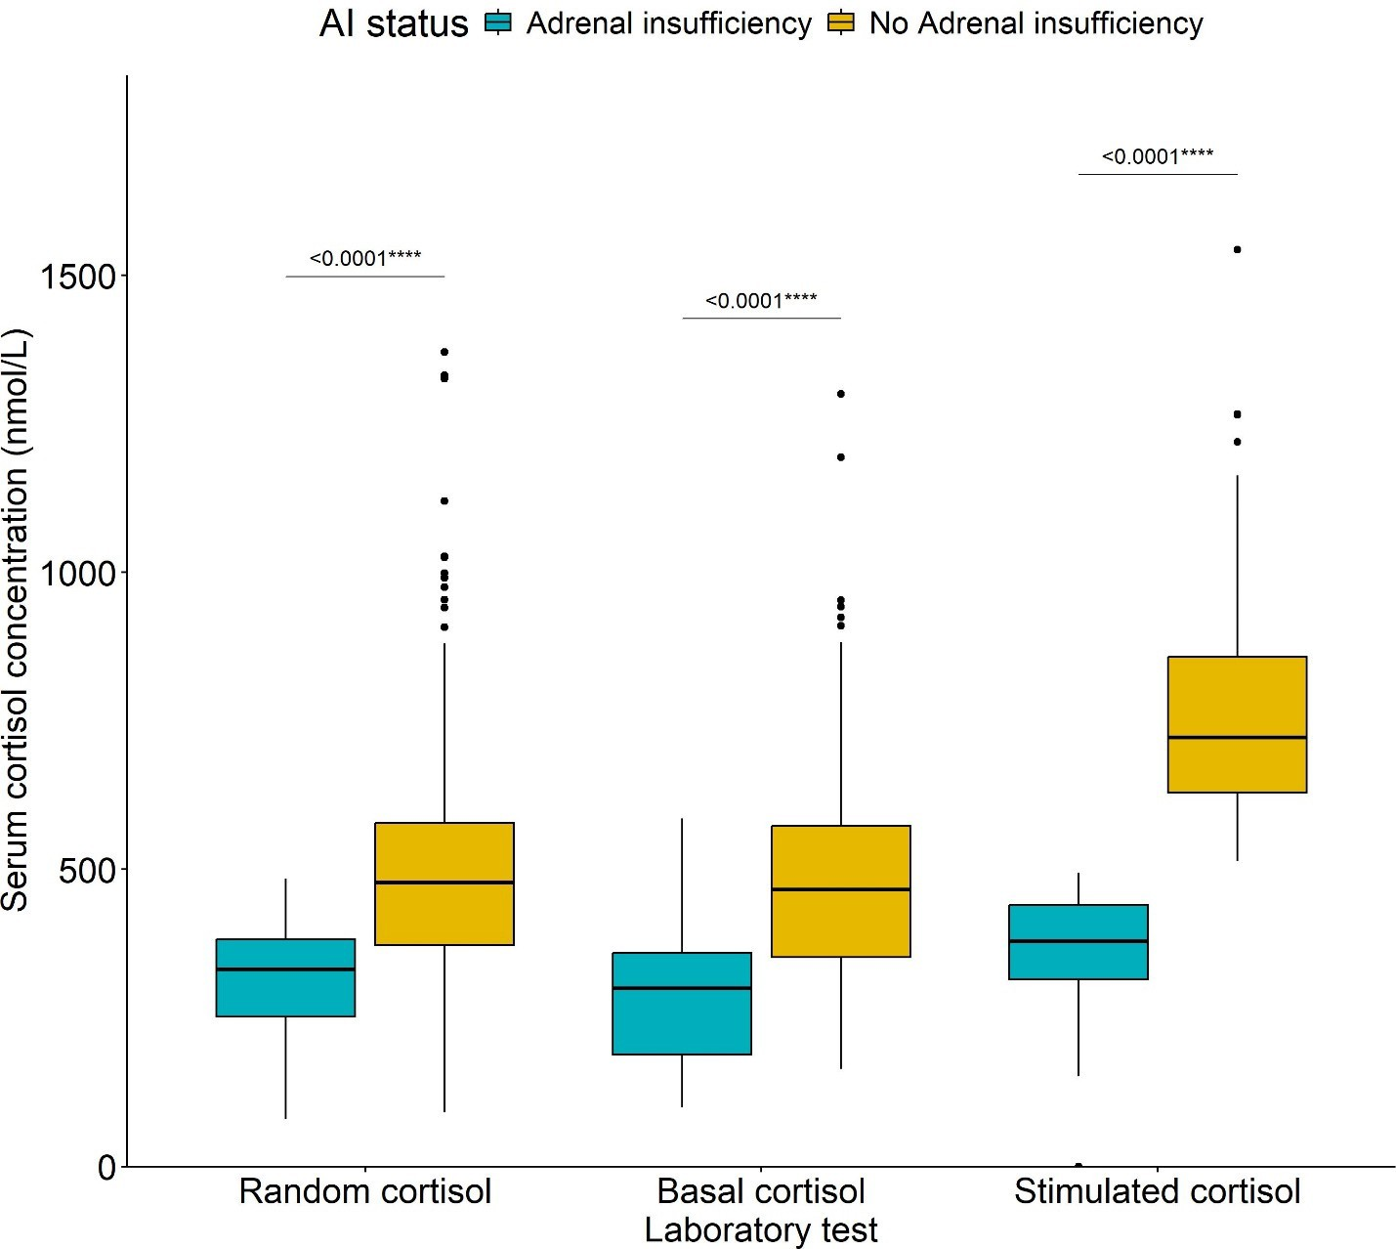

**Fig 1:** Boxplot showing the comparison of cortisol concentrations in adrenal insufficiency versus those without adrenal insufficiency in respect of the random serum, basal, stimulated cortisol concentrations and plasma ACTH. Cortisol in nmol/L and ACTH in pg/ml. **** representing *p*<0.001 and ns representing a non-significant p-value. [Adrenal insufficiency (AI), No adrenal insufficiency (No-AI)]

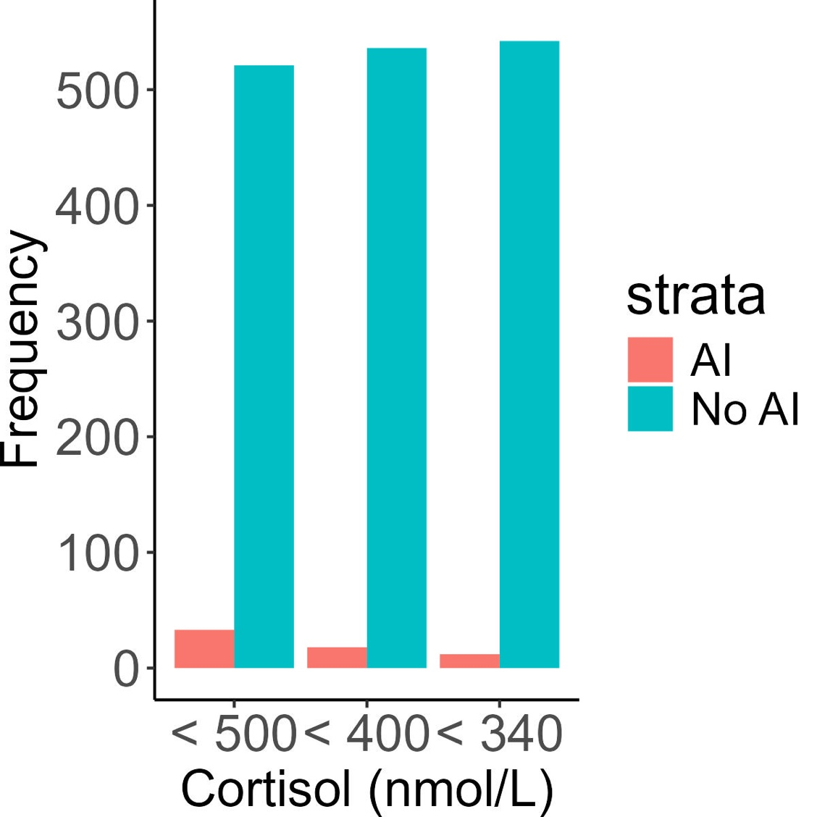

**Fig 2: A chart showing the incidence of adrenal insufficiency using the three cortisol concentration cut-offs.**

|  |  |  |  |
| --- | --- | --- | --- |
| Category | No AI | PAI | SAI |
| <500 | 521 | 9 | 24 |
| <400 | 536 | 5 | 13 |
| <340 | 542 | 3 | 9 |

**Table 4: Comparisons of the characteristics of patients who died without adrenal insufficiency versus those with AI**

The overall mortality at one-year follow-up was 11/33 (33.3%) among the AI group compared to the group without 140/521 (26.9%); (*p*=??). There was no significant difference in mortality at 3, 6 and 12 months for the two groups, respectively. There were, however, differences in the random cortisol, basal cortisol, stimulated cortisol, and incremental cortisol, with *p*=0.004, *p*<0.001, *p*<0.001 and *p*<0.004, respectively, between the subgroups of deceased patients with AI versus patients without. As expected, higher cortisol concentrations were found in patients without AI. The mortality associated with *Cryptococcal neoformans* was however greater in the AI than in the non-AI groups, 45.5% vs 4.3%; *p*=0.008.

**Table 4: Comparisons of the characteristics of patients who died without adrenal insufficiency versus those with AI**

|  |  |  |  |
| --- | --- | --- | --- |
| **Variable** | ***Non-AI, N = 1401*** | ***AI, N = 111*** |  |
| Age at enrolment, median (IQR) (years) | 37 (32, 44) | 41 (37, 48) | 0.2 |
| Female gender, n(%) | 75 (53.6%) | 6 (54.5%) | >0.9 |
| Duration of current illness, median (IQR) (days) | 14 (14, 21) | 14 (10, 14) | 0.13 |
| Random cortisol | 509 (412, 636) | 281 (244, 341) | **<0.001** |
| Basal cortisol | 483 (408, 608) | 284 (201, 365) | **<0.001** |
| Stimulated cortisol | 768 (624, 908) | 375 (321, 426) | **<0.001** |
| Incremental Cortisol | 260 (175, 356) | 32 (17, 107) | **<0.001** |
| Weight loss | 115 (89.1%) | 9 (81.8%) | 0.6 |
| Viral load (log10 Copies/mL) | 10.3 (7.6, 12.7) | 12.3 (12.3, 12.3) | 0.7 |
| Pulmonary tuberculosis | 91 (65.0%) | 5 (45.5%) | 0.2 |
| Extrapulmonary tuberculosis | 26 (18.6%) | 4 (36.4%) | 0.2 |
| Cryptococcus neoformans | 6 (4.3%) | 5 (45.5%) | **<0.001** |
| Pneumonia | 14 (10.0%) | 0 (0.0%) | 0.6 |
| Herpes simplex virus HSV | 2 (1.4%) | 0 (0.0%) | >0.9 |
| Hepatitis B | 5 (3.6%) | 1 (9.1%) | 0.4 |
| Candida | 7 (5.0%) | 1 (9.1%) | 0.5 |
| Syphilis | 4 (2.9%) | 0 (0.0%) | >0.9 |
| Pneumocystis Jiroveci Pneumonia | 2 (1.4%) | 0 (0.0%) | >0.9 |
| Total CD4 count | 28 (12, 56) | 43 (17, 67) | 0.3 |
| White cell count x109/L | 5.6 (3.8, 8.2) | 6.5 (5.3, 21.9) | 0.12 |
| Sodium mmol/L | 133.0 (129.0, | 134.0 (132.0, | 0.12 |
|  | 137.0) | 139.0) |  |
| Potassium mmol/L | 3.90 (3.50, 4.60) | 3.90 (3.65, 4.65) | >0.9 |
| Haemoglobin g/dL | 8.40 (7.10, 9.60) | 8.70 (7.45, 10.45) | 0.6 |
| Presence of anaemia | 81 (63.3%) | 6 (54.5%) | 0.7 |
| BP (systolic) | 110 (100, 123) | 127 (114, 129) | 0.073 |
| BP (diastolic) | 70 (60, 80) | 79 (67, 83) | 0.2 |
| Heart rate | 93 (80, 109) | 82 (70, 103) | 0.2 |
| Hypotension | 16 (12.4%) | 0 (0.0%) | 0.4 |
| Weakness | 113 (87.6%) | 9 (81.8%) | 0.6 |
| Tiredness | 114 (89.1%) | 11 (100.0%) | 0.6 |
| Poor appetite | 106 (82.2%) | 11 (100.0%) | 0.2 |
| Increased pigmentation of the skin | 76 (60.3%) | 4 (44.4%) | 0.5 |
| Nausea | 77 (59.7%) | 9 (81.8%) | 0.2 |
| Vomiting | 37 (28.7%) | 4 (36.4%) | 0.7 |
| Liking for salt | 77 (60.2%) | 9 (81.8%) | 0.2 |
| Hypoglycaemia | 3 (2.3%) | 0 (0.0%) | >0.9 |
| Loss of consciousness | 4 (3.1%) | 0 (0.0%) | >0.9 |
| Diarrhoea | 65 (50.4%) | 3 (27.3%) | 0.14 |
| Dizziness | 67 (52.3%) | 5 (45.5%) | 0.7 |
| Shock | 2 (1.6%) | 0 (0.0%) | >0.9 |
| Anorexia | 67 (52.3%) | 4 (36.4%) | 0.3 |
| Loss of axillary and pubic hair, if female | 33 (25.0%) | 2 (18.2%) | 0.8 |
| Any postural drop in blood pressure | 7 (5.5%) | 0 (0.0%) | >0.9 |

1Median (IQR); n (%); 2Wilcoxon rank sum test; Pearson’s Chi-squared test; Wilcoxon rank sum exact test; Fisher’s exact test

### Predictors of mortality: (NB: OR is appropriate for case-finding studies)

The increased odds of mortality was associated with skin pigmentation, nausea, poor appetite and liking of the salt. With respect to the lab tests random cortisol, ACTH, whereas opiates use and CD4 increase was protective against mortality.

The logistic regression analysis is seen in In Table 5. At, a 50 nmol/L increase in the basal cortisol was associated with a 11% increase in the odds of mortality (OR = 1.11, (95%CI:1.05, 1.18), *p*<0.001). Opiates were associated with a 44% reduction in the odds of mortality (OR = 0.56, (95%CI: 0.0.34, 0.90). Increased A 100 pg/L increase in the ACTH was associated with a 97% increase in the odds of mortality (OR = 1.97, (95%CI:1.15, 3.59); *p<*0.019).

**The multivariate analysis demonstrating factors independently predictive of mortality are shown in Table 5**.

After adjusting systolic BP, loss of consciousness, the only features which were associated with patient mortality were random cortisol and opiate use. Every 50 nmol/L increase in random cortisol was associated with a 11% higher odds of mortality (aOR = 1.11 (95%CI:1.044, 1.172) *p*<0.001) after adjusting for opiates, systolic BP, loss of consciousness. While the use of opiates was associated with a 42% reduction in the odds of mortality (aOR = 0.58 (95%CI:0.35, 0.947), *p*=0.03) after adjusting for random cortisol , systolic BP, loss of consciousness.

#### Table 5: Bivariate and Multivariable analysis of factors associated with time to mortality of patients in the entire cohort.

*Characteristic Bivariate multivariable*

|  |  |  |  |  |  |  |
| --- | --- | --- | --- | --- | --- | --- |
|  | **OR1** | **95% CI2** | ***p*-value** | **aOR3** | **95% CI2** | ***p*-value** |
| Random cortisol (per 50 units) | **1.11** | **1.05, 1.18** | **<0.001** | **1.11** | **1.044, 1.172** | **<0.001** |
| Increased skin pigmentation | **1.62** | **1.09, 2.41** | **0.018** |  |  |  |
| ACTH (per 100 pg/ml) | **1.97** | **1.15, 3.59** | **0.019** |  |  |  |
| Opiates | **0.56** | **0.34, 0.90** | **0.02** | **0.58** | **0.35, 0.947** | **0.03** |
| Poor_appetite | **1.81** | **1.11, 3.04** | **0.02** |  |  |  |
| Liking_for_salt | **1.55** | **1.05, 2.31** | **0.03** |  |  |  |
| Nausea | **1.54** | **1.04, 2.30** | **0.031** |  |  |  |
| cd4 (per 50 cell/µL) | **0.71** | **0.51, 0.99** | **0.048** |  |  |  |
| Fluconazole | 1.65 | 0.98, 2.74 | 0.057 |  |  |  |
| BP (diastolic) (per 10 units) | 1.14 | 0.99, 1.32 | 0.074 |  |  |  |
| BP (systolic) (per 10 units) | 0.91 | 0.81, 1.01 | 0.08 | 0.9 | 0.802, 1.004 | 0.058 |
| Loss_of_consciousness | 3.71 | 0.81, 19.0 | 0.089 | 3.49 | 0.73, 16.706 | 0.117 |
| Haemoglobin | 0.93 | 0.85, 1.01 | 0.093 |  |  |  |
| GE_c_diff | 0.39 | 0.09, 1.15 | 0.13 |  |  |  |
| Rifampicin | 1.53 | 0.79, 2.87 | 0.2 |  |  |  |

1 Odds Ratio; 2 95% Confidence interval; 3 Adjusted Odds Ratio

### Table 5: Bivariate and Multivariate analysis of factors associated with time to mortality of patients in the entire cohort.

*Characteristic Bivariate multivariable*

|  |  |  |  |  |  |  |
| --- | --- | --- | --- | --- | --- | --- |
|  | OR1 | 95% CI2 | *p*-value | aOR3 | 95% CI2 | *p*-value |
| **History** |  |  |  |  |  |  |
| Increased skin pigmentation | **1.65** | **1.12, 2.43** | **0.011** |  |  |  |
| discharged | **5.59** | **1.99, 23.3** | **0.005** | **4.09** | **1.17, 14.270** | **0.027** |
| Nausea | **1.59** | **1.09, 2.34** | **0.017** | 1.47 | 0.972, 2.230 | 0.068 |
| Loss of consciousness | 3.63 | 0.79, 18.6 | 0.094 | 3.81 | 0.661, 21.994 | 0.134 |
| Poor appetite | **2.01** | **1.24, 3.37** | **0.006** |  |  |  |
| Liking for salt | **1.51** | **1.03, 2.21** | **0.035** | 1.28 | 0.849, 1.929 | 0.238 |
| Diarrhoea | 1.27 | 0.87, 1.85 | 0.2 |  |  |  |
| **Clinical** |  |  |  |  |  |  |
| Presence of anaemia | 1.27 | 0.86, 1.89 | 0.2 |  |  |  |
| BP diastolic | 1.13 | 0.98, 1.31 | 0.094 | **1.36** | **1.112, 1.672** | **0.003** |
| BP systolic | 0.9 | 0.80, 1.00 | 0.063 | **0.77** | **0.663, 0.899** | **<0.001** |
| Pneumonia | 0.76 | 0.39, 1.38 | 0.4 |  |  |  |
| Hypotension | 1.4 | 0.73, 2.59 | 0.3 |  |  |  |
| **Lab tests** |  |  |  |  |  |  |
| Random cortisol | **1.13** | **1.07, 1.19** | **<0.001** | **1.12** | **1.056, 1.193** | **0.009** |
| ACTH | **1.01** | **1.00, 1.01** | **0.013** |  |  |  |
| Haemoglobin | 0.93 | 0.85, 1.00 | 0.094 |  |  |  |
| CD4 count | 0.99 | 0.99, 1.00 | 0.052 |  |  |  |
| **Drugs** |  |  |  |  |  |  |
| Fluconazole | 1.65 | 0.98, 2.74 | 0.057 |  |  |  |
| Opiates | **0.56** | **0.34, 0.90** | **0.02** | 0.61 | 0.363, 1.017 | 0.058 |

1 Odds Ratio; 2 95% Confidence interval; 3 Adjusted Odds Ratio

## Discussion: awaiting the final data analysis

To our knowledge this is the largest study looking at the incidence of adrenal insufficiency and mortality in patients with advanced HIV. Inspired by the knowledge that undiagnosed AI can be fatal in the event of complication, we sought to establish its presence and contribution to mortality in patients HIV and AIDS, to mitigate this risk through early diagnosis and intervention. Our study of adrenal insufficiency in advanced HIV revealed AI incidence of 33 out of the 155 who received the stimulation test. The majority of whom were SAI 81.81 (%). The majority of these patients received a 250 mcg tetracosactide test with a cutoff corstsol concentration of 500nmol/L using the Roche COBAS II ECLIA, while 6 patients were diagnosed on random cortisol and ACTH alone due to ???.

**The Major findings:**

1. Patients in the lower tertile were younger.
2. Overall prevalence in this cohort was 6.5% with a predominant SAI group.
3. The most common OI was PTB in Non-AI and Extra pulmonary tuberculosis and cryptococcus in the AI group.
4. Duration of illness was longer in the SAI versus PAI group.
5. Mortality was higher in the AI versus Non-AI group, though not significant.
6. The rate of death began to increase after months, and tuberculosis was the predominant cause of death in the non-AI group.

To evaluate the possibility of overdiagnosis we performed analysis using a suggested AI diagnosis cutoff of 500 nmol/L, 400 nmol/L and 340 nmol/L on the more sensitive COBAS II which yielded 33, 18 and 12 AI patients, respectively.

The overall mortality of 27.50%. The most common opportunistic infection was tuberculosis at (84%), followed by pneumonia (11.35%) and candida (6.2%). Patients with adrenal insufficiency were associated with higher risk of extrapulmonary TB and cryptococcus neoformans, both of which are AIDS- defining illnesses and potential causes of AI.

The neutrophil counts were lower in the AI versus the non-AI group and a paradoxical sodium elevation in the AI group. On the other hand, natural killer cell cytotoxicity (NKCC) lymphocyte dysfunction leading

to increased infections has been associated with adrenal insufficiency (19), and increased mortality. The observed significant cryptococcal fungal infection in the adrenal insufficiency group may be explained by both numeric and functional decline in lymphocytesThere was significantly higher opiate and fluconazole use in the AI group, both of which can reduce enzyme activity, leading to lower adrenal cortisol production. Table 3

There was a higher mortality associated with extrapulmonary tuberculosis and cryptococcus neoformans in the AI group

At multivariate analysis ACTH was significant together with lower incremental cortisol, poor appetite, nausea, liking of salt, loss of axillary hair, PJP infection in predicting mortality. This finding is consistent with a study by Christ-Crain et al (20) in which elevated cortisol levels were associated with poor outcomes in ICU patients with community acquired pneumonia (CAP).

### Strengths and Weaknesses:

### This is the biggest study on adrenal insufficiency in HIV positive patients in Africa.

### The weaknesses:

### It iis a single center study, and my thus not be generalizable.

### Unavailability of the LC/MS which is the new GOLD Standard for steroid analysis.

**Conclusion:**

The largest African study on hypoadrenalism in advanced HIV revealed overall mortality of 27.50% with 26..9 versus 33.3% non-AI and AI mortality, respectively. We feel that screening for AI is warranted in advanced HIV, to mitigate the risk of death. The majority of the opportunistic infections were tuberculosis, pneumonia and cryptococcal infection. Tuberculosis and cryptococcal infections invariably correlated with the aetiology of mortality, while elevated cortisol was associated with increased odds of death.

### Uncategorized References

1. Dunlop D. Eight-six cases of Addison's disease. British medical journal. 1963;2(5362):887.
2. Betterle C, Morlin L. Autoimmune Addison’s disease. Pediatric adrenal diseases. 2011;20:161-72.
3. Ross IL, Levitt NS. Addison’s disease symptoms–a cross sectional study in urban South Africa. PLoS One. 2013;8(1):e53526.
4. Mofokeng TR, Beshyah SA, Mahomed F, Ndlovu KC, Ross IL. Significant barriers to diagnosis and management of adrenal insufficiency in Africa. Endocrine connections. 2020;9(5):445- 56.
5. Mofokeng TRP, Ndlovu KCZ, Beshyah SA, Ross IL. Tiered healthcare in South Africa exposes deficiencies in management and more patients with infectious etiology of primary adrenal insufficiency. Plos one. 2020;15(11):e0241845.
6. Goliber T. The status of the HIV/AIDS epidemic in Sub-Saharan Africa. Population Reference Bureau. 2002.
7. Hofbauer LC, Heufelder AE. Endocrine implications of human immunodeficiency virus infection. Medicine. 1996;75(5):262-78.
8. Boulle A, Schomaker M, May MT, Hogg RS, Shepherd BE, Monge S, et al. Mortality in patients with HIV-1 infection starting antiretroviral therapy in South Africa, Europe, or North America: a collaborative analysis of prospective studies. PLoS medicine. 2014;11(9):e1001718.
9. Arlt W. Adrenal insufficiency. Clinical medicine. 2008;8(2):211.
10. Husebye ES, Pearce SH, Krone NP, Kämpe O. Adrenal insufficiency. The Lancet. 2021;397(10274):613-29.
11. Eledrisi MS, Verghese AC. Adrenal insufficiency in HIV infection: a review and recommendations. The American journal of the medical sciences. 2001;321(2):137-44.
12. Bornstein SR. Predisposing factors for adrenal insufficiency. New England Journal of Medicine. 2009;360(22):2328-39.
13. Afreen B, Khan KA, Riaz A. Adrenal insufficiency in Pakistani HIV infected patients. Journal of Ayub Medical College Abbottabad. 2017;29(3):428-31.
14. Odeniyi I, Fasanmade O, Ajala M, Ohwovoriole A. Adrenocortical function in Nigerians with human immunodeficiency virus infection. Ghana Medical Journal. 2013;47(4):171.
15. Bergthorsdottir R, Leonsson-Zachrisson M, Odén A, Johannsson G. Premature mortality in patients with Addison’s disease: a population-based study. The Journal of Clinical Endocrinology & Metabolism. 2006;91(12):4849-53.
16. Johannsson G, Falorni A, Skrtic S, Lennernäs H, Quinkler M, Monson JP, et al. Adrenal insufficiency: review of clinical outcomes with current glucocorticoid replacement therapy. Clinical endocrinology. 2015;82(1):2-11.
17. Vogeser M, Kratzsch J, Ju Bae Y, Bruegel M, Ceglarek U, Fiers T, et al. Multicenter performance evaluation of a second generation cortisol assay. Clinical Chemistry and Laboratory Medicine (CCLM). 2017;55(6):826-35.
18. Holst JP, Soldin SJ, Tractenberg RE, Guo T, Kundra P, Verbalis JG, et al. Use of steroid profiles in determining the cause of adrenal insufficiency. Steroids. 2007;72(1):71-84.
19. Bancos I, Hazeldine J, Chortis V, Hampson P, Taylor AE, Lord JM, et al. Primary adrenal insufficiency is associated with impaired natural killer cell function: a potential link to increased mortality. European journal of endocrinology. 2017;176(4):471-80.
20. Christ-Crain M, Stolz D, Jutla S, Couppis O, Müller C, Bingisser R, et al. Free and total cortisol levels as predictors of severity and outcome in community-acquired pneumonia. American journal of respiratory and critical care medicine. 2007;176(9):913-20.nb